**Final Project**

Title

**Minesweeper v.2**

Course

**CIS-17C**

Section

**48942**

Due Date

**December 20, 2015**

Author

**Edgar M Trujillo Sanchez**

**Introduction**

Title: Minesweeper v.2

Minesweeper v.2 is a single player puzzle game. Its goal is to clear a board, also called minefield, without detonating any mines. The game starts with the player being asked to provide the desired length of the minefield’s sides. Using this information, a square minefield is formed with mines randomly placed. The number of mines found in the minefield is equivalent to the length of the sides. At this point, the user must start choosing locations on the board by providing row and column numbers and either revealing the location’s contents, with the left-click option, or placing a flag on the selected location, with the right-click option. This will be repeated until the user clears the whole board or until a mine is detonated. In this version, version two, the playing time elapsed since the beginning of the game is displayed after each of the user’s moves.

The user also has the choice to restart the game or exit the game while playing. To restart the game the user must enter a ‘D’ when being asked to provide a right or left click. This will provide a new minefield with its mines at new random locations. Restarting the game will also reset the game clock to zero. To exit the game the user must enter an ‘E’ when being asked to provide a right or left click. This will exit the game immediately. The elapsed playing time will not be displayed in this case.

The user is thanked for playing before ending the game and whether the player wins, loses, or decides to exit the game. If the player wins or loses, the total playing time will be displayed.

**Summary**

Project size: 1080 lines

Number of major variables: 24

This project includes many of the concepts we have covered in class so far. For example, I used the templated vector class that we developed, through homework assignments, to implement the grid that stored the mines and the mine counts on the locations neighboring the mines. Also, I utilized the STL vector to implement the grid printed to the console screen during playtime. This grid was constantly updated and printed to the screen as the player continued to solve the minefield puzzle. The STL library fill algorithm was used to initialize the STL vector before playtime. Moreover, the STL vector’s assign function was used allocate the necessary memory for the playtime grid after the user had specified the desired size of the minefield. Lastly, I utilized a binary tree structure to implement a grid that would display the board with all of its locations’ contents hidden. This is the first grid the user sees during playtime before starting to solve the puzzle.

It was fairly challenging to develop this project. One of the main issues I had was to synchronize all of my loops for the restart game option of the game. I also had a hard time figuring out which of the STL containers was best to implement this game. Another problem I had was that I was using one-dimensional vectors to implement two-dimensional grids. In consequence, I had to utilize an offset when accessing the vectors. Moreover, the structure of this game is fairly simple and it was hard to figure out where to utilize the more advance concepts we learned in class, such as Trees and Hashing.

To complete this project it took me about three weeks and a total of about eighty hours. The reason I took that long was because I could not decide which of the advance structures was a good fit for this project.

I was able to add a playtime clock to version two of this game, which version one did not have. It keeps track of how long the player takes to solve the puzzle. Using this new feature, I could add an extra functionality to the game in the future. A highscores function could be implemented to keep track of the players that win the game in the fastest times.

**Description**

This minesweeper v.2 game was implemented using a class called Minefield. Minefield’s main components are an integer variable for the height of the minefield, an integer variable for the width of the minefield, a vector of integers created using my own templated vector implementation, an STL vector of character values, and a character type tree structure. My vector was used to create an instance of the board that stored the locations of the mines and the mine counts on the locations neighboring the mines. In this board, mines were represented by the integer value of 9. The STL vector was used to create an instance of the minefield that the player would see during playtime. In this version of the minefield, mines were represented by the character value ‘X’. The tree structure was used to create an instance of the board with its contents hidden. This version of the minefield did not include a representation of the mines.

- Sample Inputs/Outputs

All the inputs for this game are given by the user while the game is running.

Minesweeper v.2 starts by welcoming the user and asking him/her for the desired size of the minefield’s sides:

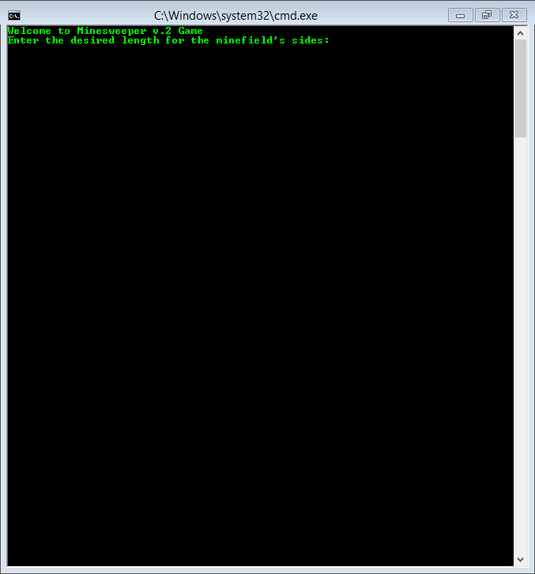

Once the user enters a valid length for the sides, the user is given the choice to see the game’s instructions or to start playing:

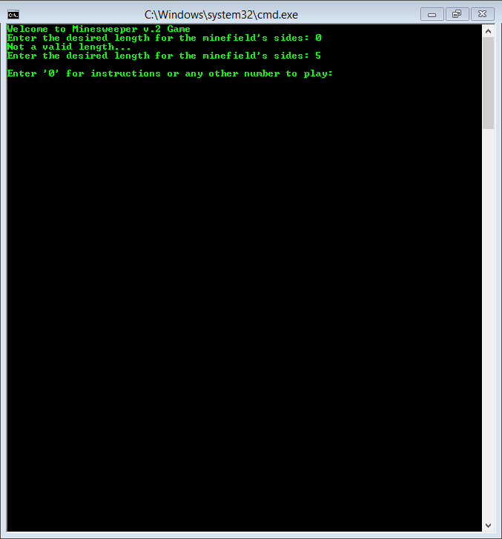

When a ‘0’ is entered, the instructions to how to play the game are displayed. After this, the user must enter any number to start playing:

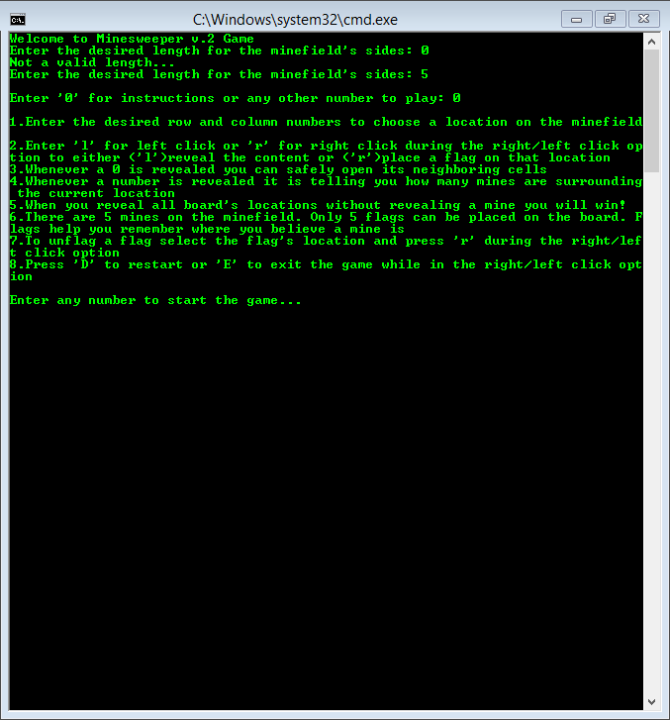

Once the user starts playing, the minefield with its contents hidden is displayed:

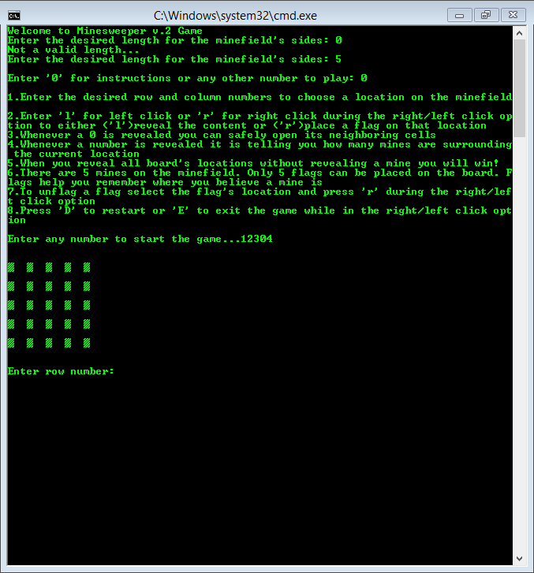

After the user selects the first location and decides whether to reveal its contents or place a flag, the console screen is cleared and only the updated minefield is displayed. Along with the update minefield, the elapsed playing time is also displayed:

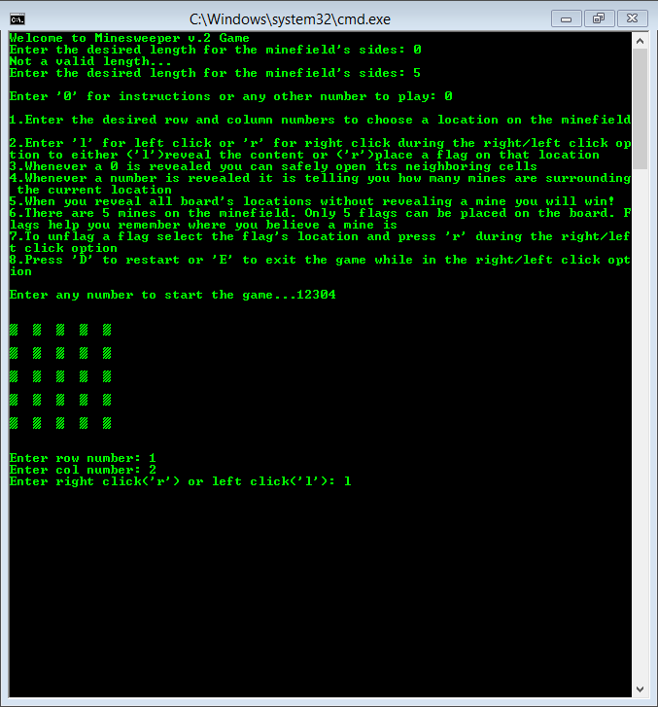

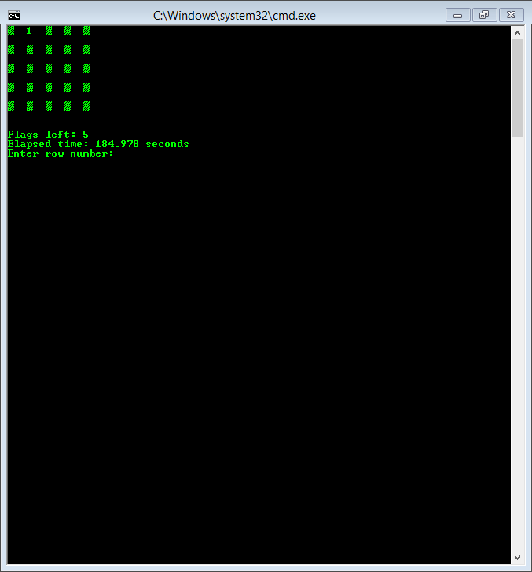

The user must continue choosing other locations and decided whether to reveal the contents of the location or place a flag. Once the user clears the whole minefield he/she wins the game. The total playing time will also be displayed:

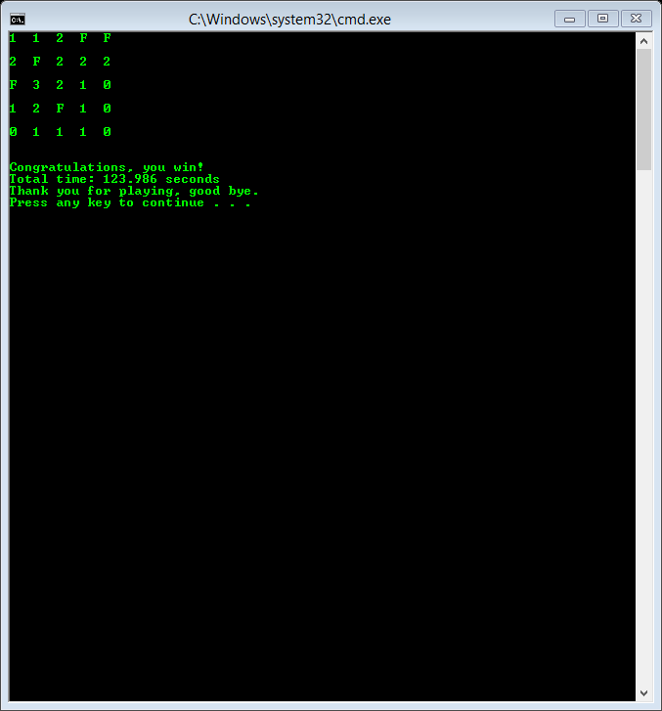

If a mine is detonated at any point, the user loses and the game ends. The total playing time will be displayed:

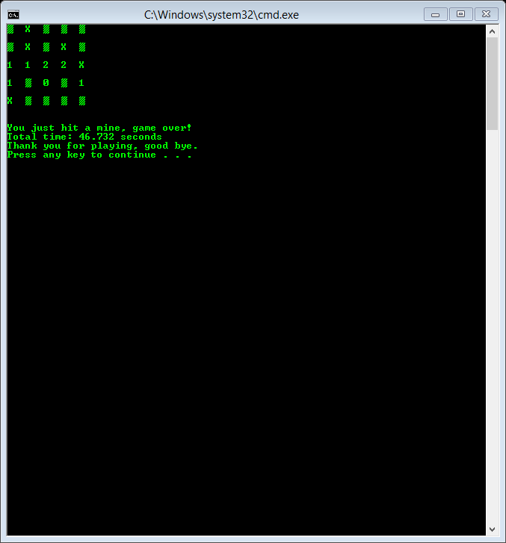

To restart or exit the game, the user must enter a ‘D’ or an ‘E’ while playing and during the right/left click option. If the game is restarted, the game clock will also be restarted. The elapsed playing time will not be displayed if the user decides to restart or exit the game:

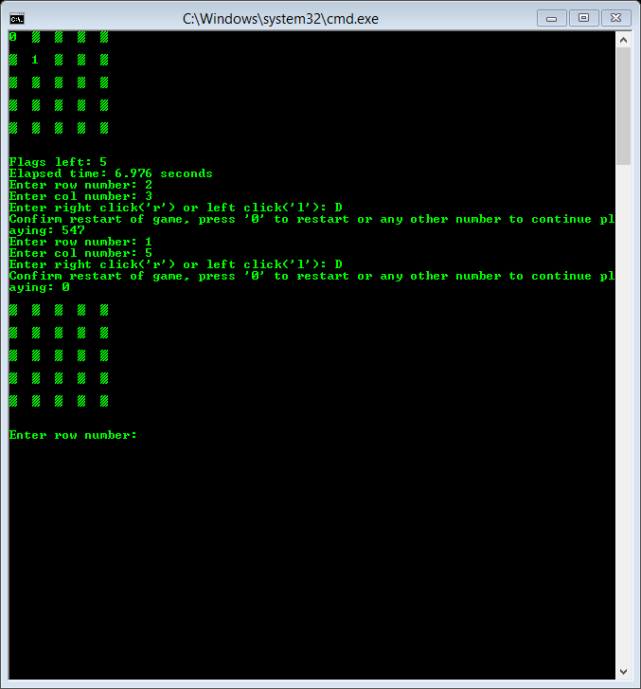

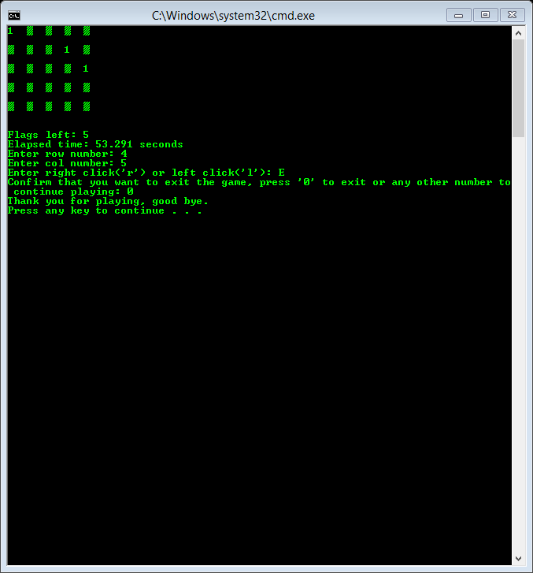

- Flowchart

if play

if help

END

minefield.endGame()

if control = false

exit game or game over

if control = true

restart game

minefield.playTime(control)

do-while loop

bool control = true;

minefield.helpPlay()

minefield.instructions()

Help or Play

minefield.setSize(length)

Set size of board

minefield.sidesLength()

user input

int main()

START

minefield.allocateGrids()

minefield.setShown()

minefield.setMines()

minefield.setCount()

minefield.printHidGrid()

minefield.printPlayGrid()

Declare Minefield object

int height=0;

int width=0;

myVector<int> grid; size=0

STL vector<char> playGrid; size=0

BinaryTree hidGrid; size=0

Get size of board

- Pseudo Code

Initialize

User is welcomed to game

A minefield object is declared

User is asked to provide a desired length for the board’s sides

If user gives a non-positive length ask user for a valid length

Else if user gives a valid length it is stored

Length is used to set size of minefield

Minefield is created and random mines are placed

User is asked if game instructions should be displayed

If user says yes, game instructions are displayed

Else if user says no, game starts

Main playtime loop starts and control is set to true

Second playtime loop starts and game clock starts

User is asked to provide the coordinates of a location in the minefield

Location’s content is revealed or flag is set

If a mine is revealed second playtime loop ends

control set to false

Else if user ends game, no changes made to minefield

control set to false

Else if user restarts game, new minefield is constructed

control set to true

Else if minefield is completely cleared, user wins

control set to false

If control is set to true the game restarts

Else if control is set to false main playtime loop ends

User is thanked and game ends

- Variables

All major variables will be separated according to the file they appear on

main.cpp

// Declaring minefield object

Minefield minefield;

//Variable holds length of the sides of the minefield

int length=0;

//Variable will determine when the game ends

bool control=true;

Minefield.h

BinaryTree hidGrid; // grid with hidden contents

MyVectorDA<int> grid; // grid with counts neighboring mines

vector<char> playGrid; // grid displayed during playtime

int height; // height of grid

int width; // width of grid

Minefield.cpp

// Variable holds length of the sides of the minefield

int length=0;

// For loop counters

int i=0;

int j=0;

//ASCII value 178

char a=178;

//counter for mines surrounding grid location

int count=0;

//counter for mines inside for loop

int mineC=0

// Choice for helpPlay function

int choice;

//will hold the user-given row number

int urow=0;

//will hold the user-given col number

int ucol=0;

//will hold user-given right/left click

char uclick=0;

//will keep track of open locations

int totalCtn=0;

//holds total number of locations

int total=grid.size();

//will keep track of how many flags are placed by user

int flagCtn=0;

//ASCII value 178 for hidden locations on playGrid

char hide=178;

// Confirm that user wants to restart/exit game

int confirm;

// holds converted int value

char temp;

*All other variables present on the files above or other files in project (MyVectorDA.h, BinaryTree.h, and BinaryTree.cpp) are used locally in the file they are found, which makes them not very important to the rest of the project.

**References**

1. Class Textbook: Introduction to Algorithms

2. Homework Assignments

3. Following websites:

-http://minesweeperonline.com

-http://www.theasciicode.com.ar/

-http://www.cplusplus.com (for STL vector and clear console screen)

-http://stackoverflow.com (converting an int to ASCII character)

-https://www.sgi.com/tech/stl/ (for STL library)

4. Another textbook: Starting Out with C++ by Tony Gaddis

**Program**

/*

* Edgar M Trujillo Sanchez

* Dec 20th, 2015

* Purpose: FinalProject - This program will simulate the game Minesweeper

* using the STL vector and some of its algorithms, as well as my own

* vector class. It will also include a binary tree structure, which uses

* recursive algorithms to display its contents.

*/

#include <iostream>

#include<ctime>

#include "Minefield.h"

using namespace std;

int main()

{

// Initialize the random number generator

srand(static_cast<unsigned int>(time(0)));

// Welcomes user to game

cout<<"Welcome to Minesweeper v.2 Game"<<endl;

// Declaring minefield object

Minefield minefield;

//// Getting length of minefield's sides

//Variable holds length of the sides of the minefield

int length=0;

length=minefield.sidesLength();

// Set size of minefield

minefield.setSize(length);

cout<<endl;

// Decide if help or play

minefield.helpPlay();

// Loop will continue looping until user wins or user decides to exit game

bool control=true;

do

{

// Allocate grids with user-given size

minefield.allocateGrids();

// Set playGrid will all locations hidden

minefield.setShown();

// Allocate hidden grid

minefield.allocateHidGrid();

// Set mines on grid

minefield.setMines();

// Set count after placing mines

minefield.setCount();

// Print grid

//minefield.printGrid();

// Print hidGrid

//minefield.printHidGrid();

// Print playGrid

minefield.printPlayGrid();

// Start playing game

minefield.playTime(control);

//end-of-line statement for when restarting the game

if(control==true)

cout<<endl;

}while(control==true);

// End of game

minefield.endGame();

return 0;

}

// Minefield class

#ifndef MINEFIELD_H

#define MINEFIELD_H

#include <iostream>

#include <vector>

#include "MyVectorDA.h"

#include "BinaryTree.h"

using namespace std;

class Minefield

{

private:

BinaryTree hidGrid;

MyVectorDA<int> grid;

vector<char> playGrid;

int height;

int width;

public:

// Default constructor

Minefield();

// Destructor declaration

~Minefield();

// Function that gets the length for the minefield's sides

int sidesLength();

// Function that sets the length of height and width of minefield

void setSize(int);

// Function that allocates the necessary memory for both grid and playGrid according to height and width

void allocateGrids();

// Function that copies the contents of playGrid before starting to play

void allocateHidGrid();

// Function that prints to screen the contents of grid

void printGrid();

// Function that prints to screen the contents of playGrid

void printPlayGrid();

// Function that prints to screen the contents of hidGrid

void printHidGrid();

// Function that fills up playGrid with ASCII value 178, all locations hidden

void setShown();

// Function that cycles through all grid locations and stores the amount of mines surrounding each

//grid location using the CountNeighbors function

void setCount();

// Function that cycles through all grid locations and counts how many mines surround given location

int countNeighbors(int, int);

// Function that sets "heigth" many mines on grid

void setMines();

// Function that displays rules of how to play game

void instructions();

// Function asks the user whether it needs help of how to play or wants to play

void helpPlay();

// Function that gets the desired location and right/left click from user, restarts/exits game

//if user chooses to. It also either reveals location's content, places a flag, removes a

//flag, ends the game if a mine is uncovered, or ends the game when player wins

void playTime(bool &);

// Function that converts an int value into a char value and returns it

char revealValue(int);

// Function that clears the console screen and prints the contents of

//playGrid with all the mines when user loses

void losePlayGrid();

// Function that clears the console screen and prints the contents of

//playGrid with all the flags when user wins

void winPlayGrid();

// Function that clears the console screen

void clearScreen();

// Function that thanks the user for playing the game

void endGame();

};

#endif

//Minefield.cpp, implementation file of class

//System Libraries

#include <iostream>

#include <string>

#include <ctime>

#include "Minefield.h"

#include "MyVectorDA.h"

using namespace std;

// Default constructor

Minefield::Minefield()

{

height=0;

width=0;

}

// Destructor

Minefield::~Minefield()

{

height=0;

width=0;

}

// SidesLength function. It gets the length for the minefield's sides

int Minefield::sidesLength()

{

// Variable holds length of the sides of the minefield

int length=0;

//Will continue looping until length is bigger than 0

while(true)

{

cout<<"Enter the desired length for the minefield's sides: ";

cin>>length;

//if user gives a length of less than one

if(length<1)

cout<<"Not a valid length..."<<endl;

//if length is valid break from loop and continue executing program

else

break;

}

return length;

}

// SetSize function. It sets the length of height and width of minefield

void Minefield::setSize(int size)

{

height=size;

width=size;

}

// AllocateGrids function. It allocates the necessary memory for both grid and

//playGrid according to height and width

void Minefield::allocateGrids()

{

grid.allocate(height*width);

playGrid.assign(height*width,'0');

}

// AllocateHidGrid function. It copies contents of playGrid before starting to play

void Minefield::allocateHidGrid()

{

for(int i=0; i<(height*width); i++)

{

char temp;

temp=playGrid[i];

hidGrid.insert(temp);

}

}

// PrintGrid function. It prints to screen the contents of grid

void Minefield::printGrid()

{

// Print contents of grid

for(int i = 0; i<height; i++)

{

for(int j=0; j<width; j++)

cout << grid.getElementAt(i*height+j) << " ";

cout<<endl<<endl;

}

cout<<endl;

}

// PrintPlayGrid function. It prints to screen the contents of playGrid

void Minefield::printPlayGrid()

{

// Print contents of playGrid

for(int i=0; i<height; i++)

{

for(int j=0; j<width; j++)

cout<<playGrid[i*height+j]<< " ";

cout<<endl<<endl;

}

cout<<endl;

}

// PrintHidGrid function. It prints to screen the contents of hidGrid

void Minefield::printHidGrid()

{

hidGrid.printInOrder();

}

// SetShown function. It fills up playGrid with ASCII value 178, all locations hidden

void Minefield::setShown()

{

char a=178; //ASCII value 178

//Using fill algorithm to initialize playGrid STL vector

fill(playGrid.begin(), playGrid.end(), a);

}

// SetCount function. It cycles through all grid locations and stores the amount

//of mines surrounding each grid location using the CountNeighbors function

void Minefield::setCount()

{

//cycle through all grid locations

for (int i= 0;i<height;i++)

{

for(int j=0; j<width; j++)

{

//if mine, no need to count

if (grid.getElementAt(i*height+j)==9)

continue;

int count=countNeighbors(i,j);

grid.operator[](i*height+j)=count;

}

}

}

// CountNeighbors function. It cycles through all grid locations and counts how many

//mines surround the given location

int Minefield::countNeighbors(int row, int col)

{

//counter for mines surrounding grid location

int count=0;

//cycle through all surrounding locations of given grid location

for (int i=row-1; i<=row+1; i++)

{

for(int j=col-1; j<=col+1; j++)

{

//bounds check

if (i<0 || i>=height || j<0 || j>=width)

continue;

//skip middle location

if (i==row && j==col)

continue;

//current location is a mine

if (grid.getElementAt(i*height+j)==9)

//increase count by one when a mine is found

count++;

}

}

//return how many mines were found

return count;

}

// SetMines function. It sets "heigth" many mines on grid

void Minefield::setMines()

{

//Will keep looping until "heigth" many mines are set on grid

for (int mineC=0; mineC<height; mineC++)

{

int row = rand() % height;

int col = rand() % width;

// If random location is already a mine, mineC decreases

// by one so another mine is set in a new location

if (grid.getElementAt(row*height+col)==9)

mineC--;

// Random location stores a mine

grid.operator[](row*height+col)=9;

}

}

// Instructions function. It displays rules of how to play game

void Minefield::instructions()

{

cout<<endl;

cout<<"1.Enter the desired row and column numbers to choose a location on the minefield"<<endl;

cout<<"2.Enter 'l' for left click or 'r' for right click during the right/left click "<<

"option to either ('l')reveal the content or ('r')place a flag on that location"<<endl;

cout<<"3.Whenever a 0 is revealed you can safely open its neighboring cells"<<endl;

cout<<"4.Whenever a number is revealed it is telling you how many mines are surrounding "<<

"the current location"<<endl;

cout<<"5.When you reveal all board's locations without revealing a mine you will win!"<<endl;

cout<<"6.There are "<<height<<" mines on the minefield. Only "<<height<<" flags can be placed "<<

"on the board. Flags help you remember where you believe a mine is"<<endl;

cout<<"7.To unflag a flag select the flag's location and press 'r' during the right/left "<<

"click option"<<endl;

cout<<"8.Press 'D' to restart or 'E' to exit the game while in the right/left click option"<<endl;

cout<<endl;

}

// HelpPlay function. It asks the user whether it needs help of how to play or wants to play

void Minefield::helpPlay()

{

int choice;

cout<<"Enter '0' for instructions or any other number to play: ";

cin>>choice;

//Will display how to play game if user enter a '0'

if(choice==0)

{

instructions();

//Value given by user will not be used, this lets user know that the game will start

cout<<"Enter any number to start the game...";

cin>>choice;

cout<<endl<<endl;

}

else

cout<<endl<<endl;

}

// PlayTime function. It gets the desired location and right/left click from user, restarts/exits

//game if user chooses to. It also either reveals location's content, places a flag, removes a

//flag, ends the game if a mine is uncovered, or ends the game when player wins

void Minefield::playTime(bool &set)

{

int urow=0; //will hold the user-given row number

int ucol=0; //will hold the user-given col number

char uclick=0; //will hold user-given right/left click

int totalCtn=0;//will keep track of open locations

int total=grid.size();//holds total locations

int flagCtn=0;//will keep track of how many flags are placed by user

char hide=178; //ASCII value 178 for hidden locations on playGrid

float seconds=0;

// Will keep looping until a mine is uncovered, until the user wins, or if the user decides

//to restart or exit the game

for(int i=1; i>0; i++)

{

clock_t t1,t2;

t1=clock();

//Getting desired location from user and either right/left click

cout<<"Enter row number: ";

cin>>urow;

cout<<"Enter col number: ";

cin>>ucol;

cout<<"Enter right click('r') or left click('l'): ";

cin>>uclick;

//Decrease urow and ucol by one to match memory "coordinates"

urow--;

ucol--;

//Check if the location's "coordinates" are in-bounds

if(urow<0||urow>=height||ucol<0||ucol>=height)

continue;

////// Options if user wants to restart/exti game

//Restart game

if(uclick=='D'||uclick=='d')

{

int confirm;

cout<<"Confirm restart of game, press '0' to restart or any other number to continue playing: ";

cin>>confirm;

//If restart the game is confirmed

if(confirm==0)

{

//Set=true to restart game

set=true;

//Breaks for-loop and ends function

break;

}

//User decideds not to restart the game

else

//Skips all code after and starts a new iteration of for-loop

continue;

}

//Exit game

else if(uclick=='E'||uclick=='e')

{

int confirm;

cout<<"Confirm that you want to exit the game, press '0' to exit or any other number to continue playing: ";

cin>>confirm;

//If exit the game is confirmed

if(confirm==0)

{

//Set=false to exit game

set=false;

//Breaks for-loop and ends function

break;

}

//User decideds not to exit the game

else

//Skips all code after and starts a new iteration of for-loop

continue;

}

//If left click and chosen location is not a mine

if(uclick=='l'&&grid.getElementAt(urow*height+ucol)!=9&&playGrid[urow*height+ucol]==hide)

{

//temp2 holds current grid value

int temp2=grid.getElementAt(urow*height+ucol);

//current location of playGrid set to char version of variable temp2

playGrid[urow*height+ucol]=revealValue(temp2);

//increases total count by one

totalCtn++;

}

//Placing a flag

else if(uclick=='r'&&playGrid[urow*height+ucol]!='F'&&flagCtn<height)

{

playGrid[urow*height+ucol]='F'; //places flag on chosen location

totalCtn++; //increases total count by one

flagCtn++; //increases flag count by one

}

//Removing a flag

else if(uclick=='r'&&playGrid[urow*height+ucol]=='F')

{

playGrid[urow*height+ucol]=hide; //removes flag by hiding chosen location

totalCtn--; //decreases total count by one

flagCtn--; //decreases flag count by one

}

//Chosing a mine

else if(uclick=='l'&&grid.getElementAt(urow*height+ucol)==9&&playGrid[urow*height+ucol]!='F')

{

//function that clears screen and prints playGrid with all mines

losePlayGrid();

cout<<"You just hit a mine, game over!"<<endl;

//Calculate and display elapsed time of game

t2=clock();

float diff((float)t2-(float)t1);

seconds=seconds+diff/CLOCKS_PER_SEC;

cout<<"Total time: "<<seconds<<" seconds"<<endl;

//Set=false to exit game

set=false;

//Breaks for-loop and ends function

break;

}

//Check if all user has win game

if(totalCtn==total)

{

//function that clears screen and prints playGrid with all flags

winPlayGrid();

cout<<"Congratulations, you win!"<<endl;

//Calculate and display elapsed time of game

t2=clock();

float diff((float)t2-(float)t1);

seconds=seconds+diff/CLOCKS_PER_SEC;

cout<<"Total time: "<<seconds<<" seconds"<<endl;

//Set=false to exit game

set=false;

//Breaks for-loop and ends function

break;

}

//function that clears the console screen

clearScreen();

//function that prints current version of playGrid

printPlayGrid();

//flags left to place on minefield

cout<<"Flags left: "<<height-flagCtn<<endl;

//Calculate and display elapsed time of game

t2=clock();

float diff((float)t2-(float)t1);

seconds=seconds+diff/CLOCKS_PER_SEC;

cout<<"Elapsed time: "<<seconds<<" seconds"<<endl;

}

}

// RevealValue function. It converts an int value into a char value and returns it.

char Minefield::revealValue(int value)

{

char temp;

// All possible values of variable value should be between 0-8

for(int i=0; i<=8; i++)

{

if(value==i)

// Converts int(i) into char(temp)

temp='0'+i;

}

return temp;

}

// LosePlayGrid function. It clears the console screen and prints the contents

//of playGrid with all the mines when user loses

void Minefield::losePlayGrid()

{

//This clears the console screen

clearScreen();

// Print contents of playGrid with all mines

for(int i=0; i<height; i++)

{

for(int j=0; j<width; j++)

{

// If grid's current location is a mine, set playGrid's current location to 'X'

if(grid.getElementAt(i*height+j)==9)

playGrid[i*height+j]='X';

cout<<playGrid[i*height+j]<< " ";

}

cout<<endl<<endl;

}

cout<<endl;

}

// WinPlayGrid function. It clears the console screen and prints the contents of

//playgrid with all the flags when user wins

void Minefield::winPlayGrid()

{

//This clears the console screen

clearScreen();

// Print contents of playGrid with all flags

for(int i=0; i<height; i++)

{

for(int j=0; j<width; j++)

{

// If grid's current location is a mine, set playGrid's current location to 'F'

if(grid.getElementAt(i*height+j)==9)

playGrid[i*height+j]='F';

cout<<playGrid[i*height+j]<< " ";

}

cout<<endl<<endl;

}

cout<<endl;

}

// EndGame function. It thanks the user for playing

void Minefield::endGame()

{

cout<<"Thank you for playing, good bye."<<endl;

}

// ClearScreen function. It clears the console screen

void Minefield::clearScreen()

{

//Windows OS specific, might need to change

system("CLS");

}

// MyVectorDA class template

#ifndef MYVECTORDA_H

#define MYVECTORDA_H

#include <iostream>

#include <new> // Needed for bad_alloc exception

#include <cstdlib> // Needed for the exit function

using namespace std;

template <class T>

class MyVectorDA

{

private:

T *aptr; // To point to the allocated array

int arraySize; // Number of elements in the array

void memError(); // Handles memory allocation errors

void subError(); // Handles subscripts out of range

public:

// Default constructor

MyVectorDA()

{

aptr = 0; arraySize = 0;

}

// Constructor declaration

MyVectorDA(int);

// Copy constructor declaration

MyVectorDA(const MyVectorDA &);

// Destructor declaration

~MyVectorDA();

// Accessor to return the array size

int size() const

{

return arraySize;

}

// Allocate memory

void allocate(int );

// Accessor to return a specific element

T getElementAt(int position);

// Overloaded [] operator declaration

T &operator[](const int &);

// Overloaded = (Assignment) Operator

MyVectorDA &operator= (const MyVectorDA &);

// Function that adds a new item into the array

void push(int &, int&, T, MyVectorDA &);

// Function that deletes the last item added into the array

void pop(int &);

// Function that sorts the Vector from smallest to biggest value

void markSrt(int);

};

//***********************************************************

// Constructor for SimpleVector class. Sets the size of the *

// array and allocates memory for it. *

//***********************************************************

template <class T>

MyVectorDA<T>::MyVectorDA(int s)

{

arraySize = s;

// Allocate memory for the array.

try

{

aptr = new T[s];

}

catch (bad_alloc)

{

memError();

}

// Initialize the array.

for (int count = 0; count < arraySize; count++)

*(aptr + count) = 0;

}

//*******************************************

// Copy Constructor for SimpleVector class. *

//*******************************************

template <class T>

MyVectorDA<T>::MyVectorDA(const MyVectorDA &obj)

{

// Copy the array size.

arraySize = obj.arraySize;

// Allocate memory for the array.

aptr = new T[arraySize];

if (aptr == 0)

memError();

// Copy the elements of obj's array.

for (int count = 0; count < arraySize; count++)

*(aptr + count) = *(obj.aptr + count);

}

//**************************************

// Destructor for SimpleVector class. *

//**************************************

template <class T>

MyVectorDA<T>::~MyVectorDA()

{

if (arraySize > 0)

delete[] aptr;

arraySize=0;

}

//*******************************************************

// memError function. Displays an error message and *

// terminates the program when memory allocation fails. *

//*******************************************************

template <class T>

void MyVectorDA<T>::memError()

{

cout << "ERROR:Cannot allocate memory.\n";

exit(EXIT_FAILURE);

}

//***********************************************************

// subError function. Displays an error message and *

// terminates the program when a subscript is out of range. *

//***********************************************************

template <class T>

void MyVectorDA<T>::subError()

{

cout << "ERROR: Subscript out of range.\n";

exit(EXIT_FAILURE);

}

// Allocate memory

template <class T>

void MyVectorDA<T>::allocate(int s)

{

arraySize = s;

// Allocate memory for the array.

try

{

aptr = new T[s];

}

catch (bad_alloc)

{

memError();

}

// Initialize the array.

for (int count = 0; count < arraySize; count++)

*(aptr + count) = 0;

}

//*******************************************************

// getElementAt function. The argument is a subscript. *

// This function returns the value stored at the sub- *

// cript in the array. *

//*******************************************************

template <class T>

T MyVectorDA<T>::getElementAt(int sub)

{

if (sub < 0 || sub >= arraySize)

subError();

return aptr[sub];

}

//*******************************************************

// Overloaded [] operator. The argument is a subscript. *

// This function returns a reference to the element *

// in the array indexed by the subscript. *

//*******************************************************

template <class T>

T &MyVectorDA<T>::operator[](const int &sub)

{

if (sub < 0 || sub >= arraySize)

subError();

return aptr[sub];

}

// Overloaded = (Assignment) Operator

template <class T>

MyVectorDA<T> &MyVectorDA<T> :: operator= (const MyVectorDA &a)

{

// Copy the array size.

arraySize = a.arraySize;

// Allocate memory for the array.

aptr = new T[arraySize];

if (aptr == 0)

memError();

// Copy the elements of a's array.

for(int count = 0; count < arraySize; count++)

*(aptr + count) = *(a.aptr + count);

return *this; // Returning current object

}

// Push function. It adds a new item into the array

template <class T>

void MyVectorDA<T>::push(int &current, int &usage, T nItem, MyVectorDA & obj)

{ //Regular push, new item added into array

if (usage < current)

{

operator[](usage) = nItem;

usage++;

}

//Complex push, array size is doubled before addding new item into array

else if (usage = current)

{

current = current * 2; //double the current size of array

int* temp = new int[current]; //create a temporary array to store current contents of array

//copy current contents of array into temp array

for (int i = 0; i<usage; i++)

temp[i] = obj.operator[](i);

//initiallize unused space on temp array to 0

for (int i = usage; i<current; i++)

temp[i] = 0;

temp[usage] = nItem;//copy new item into next avaliable index on array

arraySize = current;//change original array size to new current size

usage++;//increase usage counter

delete[] obj.aptr;//delete old original array

obj.aptr = temp;//point original array's pointer to temp array

}

else

{

cout << "ERROR: There's no more space on the array.\n";

exit(EXIT_FAILURE);

}

}

// Pop function. It deletes the last item added into the array

template <class T>

void MyVectorDA<T>::pop(int &usage)

{ //pops one item from array

if (usage >= 0)

{

operator[](usage - 1) = 0;

usage--;//decrease usage counter

}

else

{

cout << "ERROR: There's no more items on the array that can be pop.\n";

exit(EXIT_FAILURE);

}

}

// MarkSort function. It sorts the Vector from smallest to biggest value

template <class T>

void MyVectorDA<T>::markSrt (int n)

{

for(int position=0; position<n-1; position++)

{

for(int next=position+1; next<n; next++)

{

if(*(aptr+position) > *(aptr+next) )

{

int temp=*(aptr+position);

*(aptr+position)=*(aptr+next);

*(aptr+next)=temp;

}

}

}

}

#endif

// BinaryTree class

#ifndef BINARYTREE_H

#define BINARYTREE_H

//System Libraries

#include <iostream>

using namespace std;

class BinaryTree

{

private:

struct TreeNode

{

char value; // The value in node

TreeNode *left; // Pointer left child node

TreeNode *right; // Pointer right child node

};

TreeNode *root; // Pointer to root node

int treeSize;

void insert(char , TreeNode *);

void destroyTree(TreeNode *);

void printInOrder(TreeNode *) const;

void printPreOrder(TreeNode *) const;

void printPostOrder(TreeNode *) const;

public:

// Constructor

BinaryTree();

// Destructor

~BinaryTree();

// Public insert function

void insert(char );

// Search function

bool search(char );

// Public destroyTree function

void destroyTree();

// Public printInOrder function

void printInOrder() const;

// Public printPreOrder function

void printPreOrder() const;

// Public printPostOrder function

void printPostOrder() const;

};

#endif

//BinaryTree.cpp, implementation file of class

//System Libraries

#include "BinaryTree.h"

// Constructor

BinaryTree::BinaryTree()

{

root=NULL;

treeSize=0;

}

// Destructor

BinaryTree::~BinaryTree()

{

destroyTree();

}

// Public destroyTree function. It calls the recursive destroyTree function

//which will actually delete all the nodes of the tree

void BinaryTree::destroyTree()

{

destroyTree(root);

}

// Private destroyTree function. It will delete all the nodes of the tree

void BinaryTree::destroyTree(TreeNode *leaf)

{

if(leaf!=NULL)

{

destroyTree(leaf->left);

destroyTree(leaf->right);

delete leaf;

}

}

// Public insert function. It handles the case when the root of the tree is

//empty. If not empty calls recursive insert function

void BinaryTree::insert(char val)

{

if(root!=NULL)

insert(val, root);

else

{

root=new TreeNode;

root->value=val;

root->left=NULL;

root->right=NULL;

treeSize++;

}

}

// Private insert function. It moves down the tree by calling itself while

//searching for correct location. Once a new TreeNode is created the

//function will not call itself again.

void BinaryTree::insert(char val, TreeNode *leaf)

{

// If new value is less than current value

if(val<leaf->value)

{

if(leaf->left!=NULL)

insert(val, leaf->left);

else

{

leaf->left=new TreeNode;

leaf->left->value=val;

//Sets left child of child node to null

leaf->left->left=NULL;

//Sets right child of child node to null

leaf->left->right=NULL;

treeSize++;

}

}

// If new value is greater or equal to current value

else if(val>=leaf->value)

{

if(leaf->right!=NULL)

insert(val, leaf->right);

else

{

leaf->right=new TreeNode;

leaf->right->value=val;

//Sets left child of child node to NULL

leaf->right->left=NULL;

//Sets right child of child node to NULL

leaf->right->right=NULL;

treeSize++;

}

}

}

// Search function. It moves down the tree

//searching for given value

bool BinaryTree::search(char val)

{

TreeNode *p = root;

while(p)

{

if(p->value==val)

return true;

else if(val<p->value)

p=p->left;

else

p=p->right;

}

return false;

}

// Public printInOrder function

void BinaryTree::printInOrder() const

{

printInOrder(root);

}

// Public printPreOrder function

void BinaryTree::printPreOrder() const

{

printPreOrder(root);

}

// Public printPostOrder function

void BinaryTree::printPostOrder() const

{

printPostOrder(root);

}

// Private printInOrder function. It prints the value of the tree in InOrder.

void BinaryTree::printInOrder(TreeNode *p) const

{

if(p)

{

printInOrder(p->left);

cout << p->value << endl;

printInOrder(p->right);

}

}

// Private printPreOrder function. It prints the value of the tree in PreOrder.

void BinaryTree::printPreOrder(TreeNode *p) const

{

if(p)

{

cout << p->value << endl;

printPreOrder(p->left);

printPreOrder(p->right);

}

}

// Private printPostOrder function. It prints the value of the tree in PostOrder.

void BinaryTree::printPostOrder(TreeNode *p) const

{

if(p)

{

printPostOrder(p->left);

printPostOrder(p->right);

cout << p->value << endl;

}

}